**PREDICTION**

The last and final step is to make use of our saved model to do predictions. For that we have a class in keras called load_model. Load_model is used to load our saved model h5 file (alert.h5).

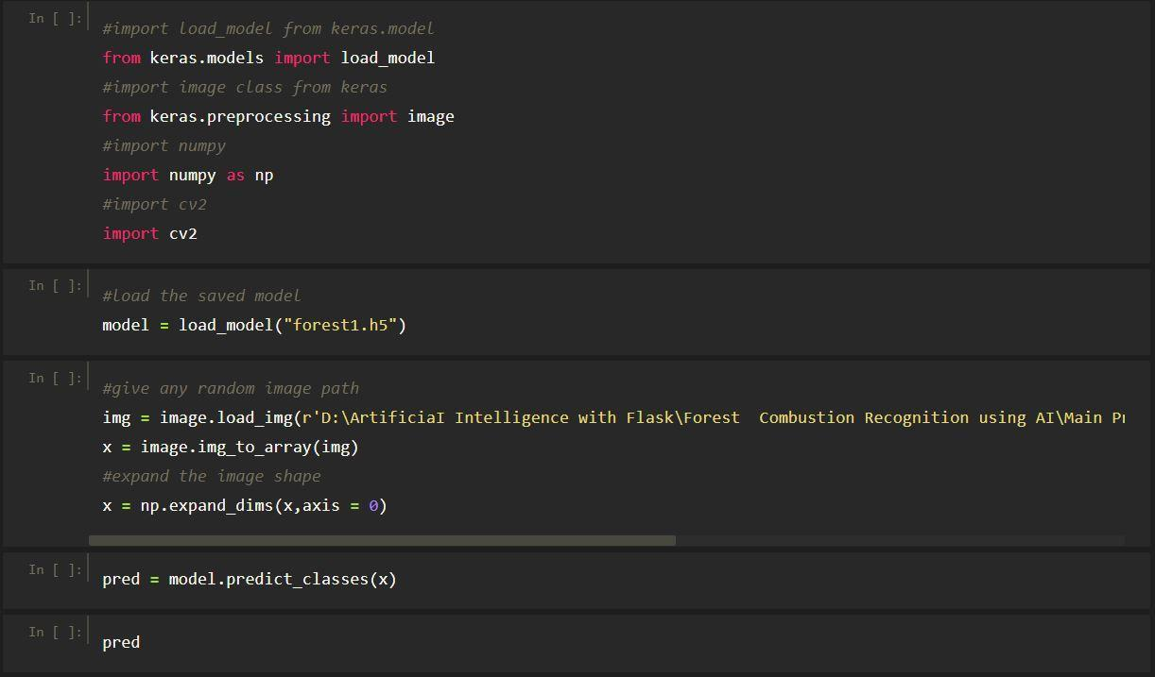

* A prediction is a guess about what might happen in the future, based on observations that you make.
* Predicting is closely related to other process skills such as observing, inferring, and classifying.
* Prediction of forest fire id expected to reduce the impact of forest fire in the future.
* Many fire detection algorithms are available with different approach towards the detection of fire.
* In the existing work processes the fire affected region is predicted based on the satellite images.